
Research Interests
We are interested in understanding how the process of alternative RNA splicing (a fundamental step of gene expression) is de-regulated in cancer and other genetic diseases, and how the proteins that control this process (splicing factors) contribute to cancer development and progression. We use both in vitro and in vivo cellular and animal model systems to identify the role of splicing factors in human diseases. A major effort in the lab is to translate our molecular findings into therapy. Based on the knowledge we have gathered, identifying oncogenic splicing factors and cancer-promoting splicing events that drive cancer development and progression, we are developing methods to intervene in this process. We have developed decoy oligonucleotides, as well as small molecules, to modulate the activity of oncogenic splicing factors and splice-switching antisense oligonucleotides to modulate oncogenic splicing events. An additional research direction aimed to inhibit cancer involves the generation of neoantigens to enhance immunotherapy by splicing modulation.
Another research effort in the lab focuses on understanding the regulation of mRNA stability by m6A RNA modifications and using its modulation to stabilize mutant genes for the treatment of both genetic diseases, such as Duchenne Muscular Dystrophy, as well as specific cancers.
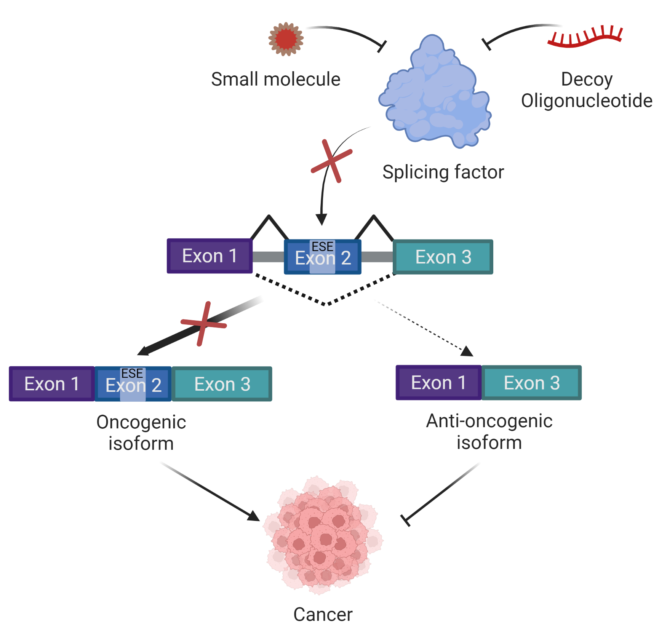
Several of these applications have been patented and are being commercialized Three biotech companies were founded based on some of our RNA therapeutics technologies: SKIP therapeutics, Andlit Therapeutics and RNAble.
Targeting splicing factors using decoy oligonucleotides or small molecules.
Dysregulated/mutated splicing factors can bind to a specific motif within the pre-mRNA and induce inclusion/skipping of exons, leading to the generation of tumor promoting oncogenic isoforms. Small molecules or decoy oligonucleotides can be used to inhibit the activity of the splicing factor, shifting the balance towards the generation of anti-oncogenic isoforms, thus inhibiting cancer.

Current Projects
1. Identification and characterization of splicing changes that occur during cancer progression and their contribution to the metastatic process.
2. Development of new RNA-based therapies for neurodevelopmental genetic diseases caused by mutations in the splicing factor HNRNPH2 and PCDH19.
3. Development of specific splicing factor inhibitors (decoy oligonucleotides) as novel anti-cancer therapy for AML and breast cancer.
4. Enhancing immunotherapy by splicing modulation.
5. Modulation of m6A RNA modification to inhibit mRNA degradation in genetic diseases and cancer.

Laboratory Members


Prof. Rotem Karni
Group leader
Office: RNA innovation institute, One Ucity Square
Room 4018
Phone: 929-501-4922
E-mail rotem.karni@pennmedicine.upenn.edu


Dr. Lee Roth
Lab Manager
RNA innovation institute, One Ucity Square
E-mail: Lee.Roth@PennMedicine.upenn.edu


Dr. Manar Abu Diab
Post Doc. fellow



Elizabeth Talker
Ph.D. student

Former Lab Members

Post-docs and research associates

Ilana Loinger-Lebenthal (2010-2013, postdoc) Bioinformatics Unit, Bar Ilan University, Israel.
Regina Golan-Gerstl (2008-2014, postdoc) Director of the Pediatric Lab, Hadassah Hospital, Israel.

Pushkar Malakar (2013-2019, postdoc) Assistant Professor, RKMVERI, Kolkata, India.

Vivek Gupta (2019-2021, postdoc) Medsource Ozone Biomedical, Haryane, India.

Ela Elyada (2020-2023, Research associate) Preclinical Pharmacology Project Leader · Teva Pharmaceuticals, Israel.
Asaf Shilo (2023-2024, Research associate)

PhD students

Ariel Sebag-Shimoni (2013) Research Associate, Chaim Sheba Medical Center, Israel.
Avi Maimon (2014) Research Associate, Weizmann Institute, Israel.

Asaf Shilo (2015) Research Associate, Hebrew University Medical School, Israel.
Vered Ben-Hur (2015) Pharma Regulation Projects Manager, Gsap Medlogic ltd., Israel.

Polina Cohen-Denichenko (2018) Medical Affairs Manager, Medison Pharma, Israel.

Maxim Mogilevsky (2020) Project Leader, NanoGhost, Israel.

Adi Mogilevsky (2023) Medical Affairs Manager, Medison Pharma, Israel.

Amina Jbara (2023) Post-doctoral fellow, Stanford University, USA.

Adi Amar-Schwartz (2023) Scientist, Anima Biotech.

M.Sc. students

Michal Cohen-Eliev (2012) Clinical Research Coordinator, Shaare Zedek Medical Center, Israel.
Lital Chartarifsky (2013) Medical Director – FCBCURE, USA.
Liat Hai-Katvan (2015) Dietician, Kupat Cholim Clalit, Israel.

Itamar Kozlowski (2017) PhD student, Hebrew University, Israel

Saja Shaqir (2021)

Adi Shtir (2023)

Reut Japha (2023) Ph.D. student Bar Ilan University.

Shivang Khandelwal (2024) Ph.D. student, Sabatini lab, Prague.

